**Individual Development Journal**

**Pillage the Kingdom**

**Dongming Liu**

**14868762**

Contents

4/10/2017 Team meeting (12 – 2pm) 1

5/10/2017 Team meeting (11am-1pm) 2

6/10/2017 Team meeting (8am-11.30am) 2

11/10/2017 Class (12 – 2pm) 2

Troop 3

Normal Troop 3

TroopFactory 3

18/10/2017 In Class Demo 4

# 4/10/2017 Team meeting (12 – 2pm)

Entire team working on the GDD. By google documents each team members can edit GDD file.

First, we name our game as ‘Pillage the Kingdom’. Continually, We done a lot of research and listed all the details as specific as we can. For example, Troops. We all agree that we make 3 different types of troop, Normal, Tank and Protection. However, for the protection troop, as we already decide the tower only attack one troop at a time, so whether the protection troop can absorb the damage or give all the other troops a shield that can immunity for a short time is a problem.

We plan to only create 1 map now and once we successes we can add more features into it for example generate different maps or different position of towers. Currently we are doing a 4 x 3 maps (as shown below), the starting point and ending point will be randomly located in the first column and last column.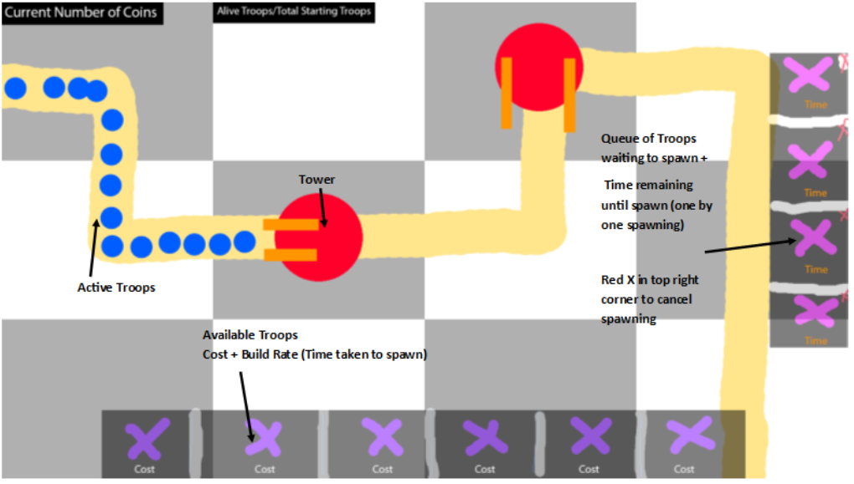

# 5/10/2017 Team meeting (11am-1pm)

Meeting goal today: Finish GDD and TDD also split work into 4 people so that everyone can start coding during the weekend.

Once again to finalize some of the details, so that each team members are agreed.

# 6/10/2017 Team meeting (8am-11.30am)

Meeting goal today: Complete TDD and GDD and Schedule.

# 11/10/2017 Class (12 – 2pm)

Check everyone’s work since last meeting.

I finished my ‘troop’ part.

## Troop

Needs

* 1. Inherited from Entity
  2. To be as abstract as possible
  3. Contains an Enum with (moving, Acting, Halted)
  4. Process method calls abstract methods (e.g. Move(), Act(), Halt())
  5. A method to switch between states (which would be called at the end of a process iteration).

Doesn’t Need

1. Acting/Halted Methods
2. Animation class

## Normal Troop

Needs­

* 1. Inherited from troop
  2. Moving Method
  3. Be able to take in points for the process method (example: setTarget (intx, int y))
  4. Uses a velocity value (in entity) to go from its current point to the ‘target point’

Doesn’t need

* 1. Working acting/Halted methods
  2. The points will be pasted though using the map class

## TroopFactory

Needs

* 1. To be singleton (similar to LogManager)
  2. Creates a Normal Troop by calling CreateNormalTroop():

Doesn’t need

* 1. Creates a Tank troop or a Protection Troop

Notes:

1. The target point either is the middle of a tile or the edge of a tile

2. No diagonal movement (only one axis change)

3. To test this, I could give the player a coordinate, then another one once he reaches it.

# 18/10/2017 In Class Demo

Modify the Moving Method in the NormalTroop class.

Fix some errors.

Error 1: Change the point from top left centre.

Added int x = m_x + m_pAnimatedSprite->GetFrameWidth()/2.0;

int y = m_y + m_pAnimatedSprite->GetFrameHeight() / 2.0;